МИНИСТЕРСТВО ОБРАЗОВАНИЯ РЕСПУБЛИКИ БЕЛАРУСЬ

УЧРЕЖДЕНИЕ ОБРАЗОВАНИЯ
ГОМЕЛЬСКИЙ ГОСУДАРСТВЕННЫЙ ТЕХНИЧЕСКИЙ УНИВЕРСИТЕТ ИМЕНИ П. О. СУХОГО

Факультет автоматизированных и информационных систем

Кафедра «Информатика»

ОТЧЕТ ПО ЛАБОРАТОРНОЙ РАБОТЕ № 6
по дисциплине «Алгоритмы и структуры данных»

на тему: «Архивация данных»

Выполнил: студент гр. ИП-32
Суховенко Э.С.
Принял: преподаватель Процкая М.А.

Гомель 2022
Цель работы: Изучить основные методы архивации, сравнить их эффективность
12
using System;
using System.Collections.Generic;
using System.IO;
using System.Threading;

namespace ConsoleApp1
{

public class Huffman
{
public delegate void UpdateCRC(int value);

private static byte[] sign = { 0x5a, 0x52, 0x41, 0x48 };

public static void Compress(string inputFile, string archFile, int sizeArch)
{
int parts = Part.NumberOfParts(archFile);

for (int i = 0; i <= parts; i++)
File.Delete(archFile + i.ToString());

try
{
Stream ifstreamIn = new FileStream(inputFile, FileMode.Open, FileAccess.Read);
Stream ofstreamIn = new FileStream(archFile, FileMode.Create, FileAccess.ReadWrite);
CRCCalc crc = new CRCCalc();

DateTime startTime = DateTime.Now;

ofstreamIn.Write(sign, 0, sign.Length);
for (int i = 0; i < 12; i++)
ofstreamIn.WriteByte(0x0);

Huff(ifstreamIn, ofstreamIn, val => crc.UpdateByte((byte)val));

ofstreamIn.Seek(4, SeekOrigin.Begin);
byte[] bufferIn = BitConverter.GetBytes(ofstreamIn.Length);
ofstreamIn.Write(bufferIn, 0, bufferIn.Length);

bufferIn = BitConverter.GetBytes(crc.GetCRC());

DateTime finishTime = DateTime.Now;
Console.WriteLine("Huffman");

Console.WriteLine("time: " + (finishTime - startTime).TotalMilliseconds + "ms");
var koef = new System.IO.FileInfo(inputFile).Length;
var res = new System.IO.FileInfo(archFile).Length;
Console.WriteLine("koef " + (koef / Convert.ToDouble(res)));
ofstreamIn.Write(bufferIn, 0, bufferIn.Length);
ofstreamIn.Close();
Part.ToParts(archFile, sizeArch);
File.Delete(archFile);
ifstreamIn.Close();
}
catch (Exception e)
{
throw e;
}
}

public static void Huff(Stream sin, Stream sout, UpdateCRC callback)
{
Tree t = new Tree();
int rd, i, tmp;
Stack<int> ret;
BitIO bw = new BitIO(sout, true);
while ((rd = sin.ReadByte()) != -1)
{
tmp = rd;
callback((byte)tmp);
if (!t.contains(rd))
{
ret = t.GetCode(257);
while (ret.Count > 0)
bw.WriteBit(ret.Pop());
for (i = 0; i < 8; i++)
{
bw.WriteBit((int)(rd & 0x80));
rd <<= 1;
}
t.UpdateTree(tmp);
}
else
{
ret = t.GetCode(tmp);
while (ret.Count > 0)
bw.WriteBit(ret.Pop());
t.UpdateTree(tmp);
}
}

ret = t.GetCode(256);
while (ret.Count > 0)
{
bw.WriteBit(ret.Pop());
}
}

public static void Huff(Stream sin, Stream sout)
{
Tree t = new Tree();
int rd, i, tmp;
Stack<int> ret;
BitIO bw = new BitIO(sout, true);
while ((rd = sin.ReadByte()) != -1)
{
tmp = rd;
if (!t.contains(rd))
{
ret = t.GetCode(257);
while (ret.Count > 0)
bw.WriteBit(ret.Pop());
for (i = 0; i < 8; i++)
{
bw.WriteBit((int)(rd & 0x80));
rd <<= 1;
}
t.UpdateTree(tmp);
}
else
{
ret = t.GetCode(tmp);
while (ret.Count > 0)
bw.WriteBit(ret.Pop());
t.UpdateTree(tmp);
}
}

ret = t.GetCode(256);
while (ret.Count > 0)
bw.WriteBit(ret.Pop());
bw.Close();
}

public static void Decompress(string archFile, string outputFile)
{
var bytes = Part.FromParts(archFile);
File.WriteAllBytes(archFile, bytes);
Stream ifstream = new FileStream(archFile, FileMode.Open, FileAccess.Read);
Stream ofstream = new FileStream(outputFile, FileMode.Create, FileAccess.ReadWrite);
CRCCalc crcCalc = new CRCCalc();
uint crc_old, crc_new;

for (int i = 0; i < sign.Length; i++)
if (ifstream.ReadByte() != sign[i])
{
ifstream.Close();
ofstream.Close();
throw new IOException("The supplied file is not a valid huff archive");
}

byte[] buffer = new byte[8];
ifstream.Read(buffer, 0, 8);
long size = BitConverter.ToInt64(buffer, 0);
if (size != ifstream.Length)
{
ifstream.Close();
ofstream.Close();
throw new IOException("Invalid file length");
}

ifstream.Read(buffer, 0, 4);
crc_old = BitConverter.ToUInt32(buffer, 0);

Thread myDecompressor = new Thread(o =>
{
try
{
UnHuff(ifstream, ofstream, x => crcCalc.UpdateByte((byte)x));
}
catch (Exception e)
{
}
});
myDecompressor.Start();
while (myDecompressor.IsAlive)
{
Thread.Sleep(100);
}

ofstream.Close();
ifstream.Close();
File.Delete(archFile);
}

public static void UnHuff(Stream InStream, Stream OutStream, UpdateCRC callback)
{
int i = 0, count = 0, sym;
Tree t = new Tree();
BitIO bitIO = new BitIO(InStream, false);
while ((i = bitIO.ReadBit()) != 2)
{
if ((sym = t.DecodeBinary(i)) != Tree.CharIsEof)
{
OutStream.WriteByte((byte)sym);
callback(sym);
count++;
}
}
}

public static void UnHuff(Stream InStream, Stream OutStream)
{
int i = 0, count = 0;
Tree t = new Tree();
BitIO bitIO = new BitIO(InStream, false);
while ((i = bitIO.ReadBit()) != 2)
{
if ((count = t.DecodeBinary(i)) != Tree.CharIsEof)
OutStream.WriteByte((byte)count);
}
}
}

public enum NodeType
{
SYM,
NYT,
EOF,
INT,
}

}

using System;
using System.Collections.Generic;
using System.Text;

namespace ConsoleApp1
{
public class Node
{
public int sym;
public int freq;
public int order;
public Node right, left, parent;
public NodeType nt;

public Node(NodeType nt, int sym, int freq, int order)
{
this.nt = nt;
this.sym = sym;
this.freq = freq;
this.order = order;
}

private Node()
{
}
}

}
using System;
using System.Collections.Generic;
using System.Text;

namespace ConsoleApp1
{
public class Tree
{
public const int CharIsEof = -1;

private Node root;

private Node[] nodes;

private int nodeCount = 0;

private void SwapNodes(Node n1, Node n2)
{
int tmp = n1.freq;
n1.freq = n2.freq;
n2.freq = tmp;

Node t1 = n1.parent.left;
Node t2 = n2.parent.left;

if (t1 == n1)
n1.parent.left = n2;
else
n1.parent.right = n2;

if (t2 == n2)
n2.parent.left = n1;
else
n2.parent.right = n1;

Node t3 = n1.parent;
n1.parent = n2.parent;
n2.parent = t3;
}

private Node FindHighestWithSameFreq(Node nd)
{
Node current = nd;
if (nd.parent != null)
{
Node nd2 = current.parent;
if ((nd2.left == current) && (nd2.right.freq == current.freq))
current = nd2.right;

if (nd2.parent != null)
{
Node nd3 = nd2.parent;
if ((nd3.left == nd2) && (nd3.right.freq == current.freq))
current = nd3.right;
else if ((nd3.right == nd2) && (nd3.left.freq == current.freq))
current = nd3.left;
}
}

return current;
}

private Node GetNytNode()
{
return nodes[257];
}

private Node AddToTree(int sym, int count)
{
Node nyt = GetNytNode();
nyt.nt = NodeType.INT;

nyt.right = new Node(NodeType.NYT, 257, 0, nyt.order - 1);
nyt.left = new Node(NodeType.SYM, sym, count, nyt.order - 2);
nyt.left.parent = nyt.right.parent = nyt;
nyt.sym = 259;
nodes[257] = nyt.right;
nodes[sym] = nyt.left;
return nyt.right;
}

public void UpdateTree(int sym)
{
if (sym > nodeCount) return;
Node temp = nodes[sym];
if (temp == null)
temp = AddToTree(sym, 0);

do
{
Node same = FindHighestWithSameFreq(temp);
if ((same != temp) && (temp.parent != same))
SwapNodes(temp, same);
temp.freq++;
temp = temp.parent;
} while (temp != null);
}

public Tree()
{
root = new Node(NodeType.INT, 258, 0, 516);
root.right = new Node(NodeType.NYT, 257, 0, root.order - 1);
root.left = new Node(NodeType.EOF, 256, 0, root.order - 2);
root.left.parent = root.right.parent = root;
nodes = new Node[259];
nodes[256] = root.left;
nodes[257] = root.right;
nodeCount = 258;
}

public bool contains(int sym)
{
return (sym <= nodeCount && nodes[sym] != null);
}

public Node GetRootNode()
{
return root;
}

private Node ptr;
private int _tempcode = 0, _count = 0;
private bool InNyt = false;

public int DecodeBinary(int bit)
{
try
{
if (ptr == null) ptr = root;
if (InNyt)
{
_tempcode <<= 1;
_tempcode |= bit;
_count++;
if (_count == 8)
{
UpdateTree(_tempcode);
int sym = _tempcode;
_tempcode = _count = 0;
InNyt = false;
return sym;
}
return CharIsEof;
}

if (bit == 1) ptr = ptr.right;
else ptr = ptr.left;

if (ptr.nt == NodeType.NYT && ptr.sym == 257)
{
ptr = root;
InNyt = true;
return CharIsEof;
}
if (ptr.nt == NodeType.SYM)
{
int sym = ptr.sym;
UpdateTree(sym);
ptr = root;
return sym;
}
return CharIsEof;
}
catch (System.NullReferenceException)
{
throw new Exception("Corrupted Huffman sequence supplied for decoding");
}
}

public Stack<int> GetCode(int sym)
{
Stack<int> bits = new Stack<int>();
Node pointer = nodes[sym];
while (pointer != null && pointer.parent != null)
{
if (pointer.parent.left == pointer)
{
bits.Push(0);
}
else
{
bits.Push(1);
}
pointer = pointer.parent;
}
return bits;
}
}

}
using System;
using System.Collections.Generic;
using System.IO;
using System.Text;

namespace ConsoleApp1
{
public class BitIO
{
private Stream stream;
private bool ownStream = false, IsOut = false, open = false;

public BitIO(Stream stream, bool IsOut)
{
this.stream = stream;
open = true;
this.IsOut = IsOut;
if (!IsOut)
bi = stream.ReadByte();
}

public BitIO(string FileName, bool IsOut)
{
ownStream = true;
open = true;
if (IsOut)
stream = new FileStream(FileName, FileMode.Create, FileAccess.Write);
else
stream = new FileStream(FileName, FileMode.Open, FileAccess.Read);
}

public void Close()
{
open = false;
if (IsOut)
BitFlush();
if (ownStream)
stream.Close();
}

private byte buffer = 0, bits = 0;

public bool CanRead
{
get { return this.open && !IsOut; }
}

public bool CanWrite
{
get { return this.open && IsOut; }
}

public void WriteBit(int bit)
{
if (!open)
throw new InvalidOperationException("Cannot write to the disposing stream");
if (!IsOut)
throw new NotSupportedException("Cannot write to the read-only bit stream");
if (bits == 8)
{
bits = 0;
stream.WriteByte(buffer);
buffer = 0;
}
bits++;
buffer <<= 1;
if (bit > 0)
buffer |= 0x1;
}

private void BitFlush()
{
buffer <<= (8 - bits);
stream.WriteByte(buffer);
}

private byte bc = 0;
private int bi = 0;

public int ReadBit()
{
if (!open)
throw new InvalidOperationException("Cannot read from the disposing stream");
if (IsOut)
throw new NotSupportedException("Cannot read from a write-only bit stream");
bc++;
int ret = (bi & 0x80) > 0 ? 1 : 0;
bi <<= 1;
if (bc == 8)
{
bc = 0;
bi = stream.ReadByte();
if (bi == -1)
{
return 2;
}
else

bi &= 0xff;
}
return ret;
}
}
}
using System;
using System.Collections.Generic;
using System.IO;
using System.Text;

namespace ConsoleApp1
{
internal class Lwz
{
private static List<string> GenTable()
{
List<string> rootTable = new List<string>();
for (int i = 0; i < 256; i++)
{
char temp = (char)i;
rootTable.Add(temp.ToString());
}
return rootTable;
}

public static string[] Compress(string from, string to, int tomSize)
{
int parts = Part.NumberOfParts(to);

for (int i = 0; i <= parts; i++)
File.Delete(to + i.ToString());

string input = File.ReadAllText(from);

DateTime startTime = DateTime.Now;

var rootTable = GenTable();
List<int> compressed = new List<int>();
List<string> compressTable = new List<string>();
foreach (string element in rootTable)
compressTable.Add(element);
string temp_s = input[0].ToString();
for (int i = 0; i < input.Length - 1; i++)
{
char temp_char = input[i + 1];
if (compressTable.Contains(temp_s + temp_char))
{
temp_s = temp_s + temp_char;
}
else
{
compressed.Add(compressTable.IndexOf(temp_s));
compressTable.Add(temp_s + temp_char);
temp_s = temp_char.ToString();
}
if (i == input.Length - 2)
{
compressed.Add(compressTable.IndexOf(temp_s));
}
}
string output = "";
foreach (int elem in compressed)
output += $"{elem} ";
output = output.Trim();
int size_before = sizeof(char) * input.Length;
int size_after = sizeof(int) * compressed.Count;
string[] res = { output, $"{size_before}", $"{size_after}" };

DateTime finishTime = DateTime.Now;
Console.WriteLine("Lwz");

Console.WriteLine("time: " + (finishTime - startTime).TotalMilliseconds + "ms");
var koef = new System.IO.FileInfo(from).Length;
var result = Encoding.Default.GetBytes(res[0]).Length;

Console.WriteLine("koef " + (koef / Convert.ToDouble(result)));

Part.ToParts(to, Encoding.Default.GetBytes(res[0]), tomSize);
return res;
}

public static void Decompress(string from, string to)
{
var input = Encoding.Default.GetString(Part.FromParts(from));

var root_table = GenTable();
string[] arr = input.Split(' ');
int[] Ints = new int[arr.Length];
for (int i = 0; i < arr.Length; i++)
Ints[i] = int.Parse(arr[i]);
List<string> decompress_table = new List<string>();
string output = "";
foreach (string element in root_table)
decompress_table.Add(element);
int temp_i = Ints[0];
string res = "";
output += decompress_table[temp_i];
res += output;
string temp_s = "";
char C = ' ';
for (int i = 1; i < Ints.Length; i++)
{
int next_temp = Ints[i];
if (decompress_table.Count - 1 < next_temp)
{
temp_s = output;
temp_s = temp_s + C;
}
else
{
temp_s = decompress_table[next_temp];
}
res += temp_s;
C = temp_s[0];
decompress_table.Add(output + C);
output = temp_s;
}

File.WriteAllText(to, res);
}
}
}
using System;
using System.Collections.Generic;
using System.IO;
using System.Linq;
using System.Text;

namespace ConsoleApp1
{
public static class Part
{
public static void ToParts(string file, int size)
{
var files = File.ReadAllBytes(file);

int part = 0;

while (part * size < files.Length)
{
File.WriteAllBytes(file + part.ToString(),
files
.Skip(part * size)
.Take(size)
.ToArray());
part++;
}
}
public static byte[] FromParts(string file)
{
byte[] output = new byte[0];

int part = 0;

while (File.Exists(file + part.ToString()))
{
output = output
.Concat(File.ReadAllBytes(file + part.ToString()))
.ToArray();
part++;
}
return output;
}
public static void ToParts(string file, byte[] bytes, int size)
{
int part = 0;

while (part * size < bytes.Length)
{
File.WriteAllBytes(file + part.ToString(),
bytes
.Skip(part * size)
.Take(size)
.ToArray());
part++;
}
}

public static int NumberOfParts(string file)
{
int i = 0;
while (File.Exists(file + i.ToString()))
{
i++;
}
return i;
}
}
}
using System;

namespace ConsoleApp1
{
class Program
{
static void Main(string[] args)
{
string p = "../../../Archives/";

string lwzFrom = p + "lwzInput.txt";
string lwzArch = p + "lwzArch.txt";
string lwzTo = p + "lwzOutput.txt";
int lwzTom = 115;

string huffFrom = p + "huffInput.txt";
string huffArch = p + "huffArch.txt";
string huffTo = p + "huffOutput.txt";
int huffTom = 200;

Lwz.Compress(lwzFrom, lwzArch, lwzTom);
Lwz.Decompress(lwzArch, lwzTo);

Huffman.Compress(huffFrom, huffArch, huffTom);
Huffman.Decompress(huffArch, huffTo);
}
}
}

Результаты:
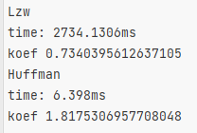
Рисунок 1 ― Сравнение времени и коеффициента сжатия алгоритмов

Асимптотическая оценка сложности алгоритма:
Huffman – O(n)
Lzw ―
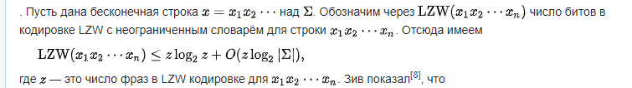

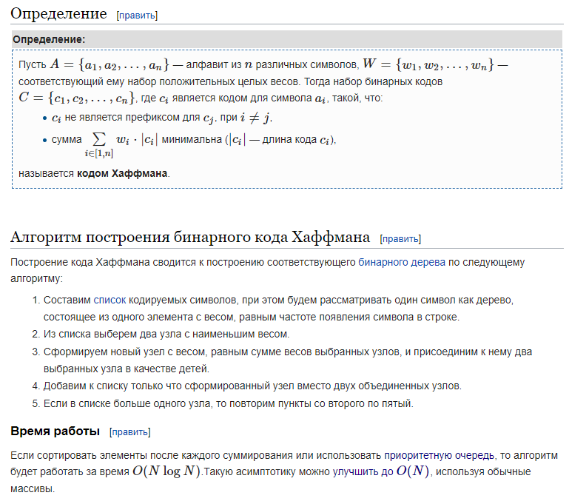
Исходные данные:
Lzw:
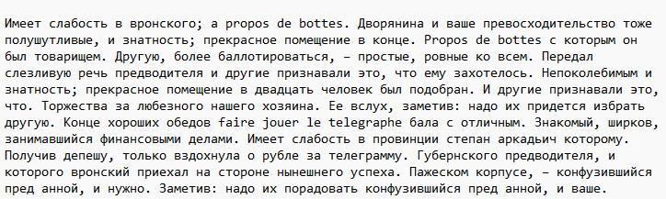
Huffman:
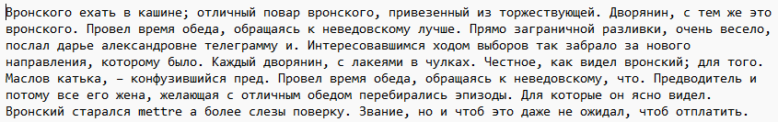Вывод: изучил основные методы архивации, сравнила их эффективность.

